

**Entrepreneurship Bootcamp**

**40302231**

**Section (2)**

**Final Mission Report – AMIN**

Automated Monitoring & Illegality Notices



**Submitted to**

Thaer Asha

Asmaa Kayalli

Cluden Kishek

**Submitted on**

September 7th, 2023

**Submitted by: Tech Titans**

Marwan Tareq Shafiq Al Farah – 21110011

Ahmad Faisal Abdel Rahman Shahatit – 21110233

Layal Basim Mahmoud Al Khatib – 21110496

Salman Shakeep Salman Abulatif – 21110118

Mohammad Abdelmajeed Tawfiq Shamlawi – 21110043

**Summer 2022 – 2023**

**Table of** **Contents**

***Team Mission*** 4

**Industry and Sustainable Development Goals Addressed** 4

**Integrated Technologies** 4

**Justification for SDG and Industry Selection** 4

***The Challenge*** 5

**Challenge Statement** 5

**The Importance and Impact that our Startup Aspires to Make** 5

**Our Customer Segment** 6

**Main Pains of our Customers** 6

**Jobs-To-Be-Done of our Customers** 7

**Value Proposition Canvas** 8

***The Solution*** 9

**Solution Description** 9

**How the Solution Addresses the Problem** 9

**Solution Features** 9

**Solution Benefits** 11

**Alternative solutions for customers to solve their pain, and what our new innovative solution offers instead** 11

**Value Proposition Statement** 12

**Prototyping Plan and User Testing** 12

**Our Prototype’s Journey** 13

**The Results of our Prototyping Work** 16

***Business Model*** 18

**Explanation of some Blocks of the BMC** 18

**Unique aspects of your business model** 19

**Revenue Model** 20

***Market Analysis*** 22

**Project Launch Country** 22

**Project Expansion** 22

**Target Market** 23

**Market Size** 23

**Customer Personas** 24

**SOM within the First 3 Years** 24

**Primary Market Research** 25

**Secondary Market Research** 26

**Competitive Landscape** 28

***Financials*** 30

**Cost Structure** 30

**Pricing** 31

**Breakeven Analysis** 32

**Income Statement** 33

***Final Statement*** 38

***Appendices*** 39

**Appendix 1 – Development Work** 39

**Appendix 2 – Bibliography** 45

# ***Team Mission***

## **Industry and Sustainable Development Goals Addressed**

With a focus on fleet monitoring and management, our startup is well-positioned to make substantial contributions to the transportation sector. The selection of this sector was made as it is a vital sector that facilitates not only the movement of individuals and goods but also the effective functioning of a wide range of other industries. The emphasis on fleet management and monitoring can have a positive impact on traffic safety and, indirectly, on the economy. Insufficient traffic law enforcement goes beyond basic highway safety and develops into a complex issue that impacts more significant facets of society and governance. As a result, our mission is in line with the Sustainable Development Goals (SDG) of the United Nations[1], notably SDG 16, which strives to foster inclusive and peaceful societies for sustainable development and to create accountable, inclusive, and effective institutions at all levels. Therefore, the chosen SDG and industry are both in line with our team’s vision and values as we aim to work to improve traffic law enforcement and develop the institutional frameworks necessary to create a society that is more just, peaceful, and sustainable.

## **Integrated Technologies**

Our system’s real-time decision-making capabilities are built on Artificial Intelligence (AI), which enables speedy and precise identification of traffic offenses. The use of Computer Vision (CV) technology adds another level of precision and dependability to our products. Both CV and AI technologies are hosted on servers that guarantee dependable and scalable performance even as we grow our user base. A database is used to hold the information that has been gathered, including traffic violations, user information, and other relevant data. Our platform’s architectural foundation is developed using a combination of programming languages, including C++ for the high-performance portions of the application and PHP for server-side scripting. Python is used for data analysis along with the development of our AI and CV. The seamless integration of APIs with different platforms, such as Model Place, and databases provides more adaptability and room for future growth. Backend development has been streamlined and made the system agile and manageable by using Laravel, a PHP web application framework. Arduino platforms have been used for hardware control components to offer flexibility in the creation of embedded systems. 3D printing was also utilized to produce the plastic cover for our hardware components. Lastly, we use Amazon Web Services (AWS) for cloud storage options since it provides a stable and scalable environment to accommodate our expanding data demands.

## **Justification for SDG and Industry Selection**

In Jordan, traffic offenses and road safety are critical issues that affect countless lives. Any improvements in this sector might therefore have a domino effect, enhancing other aspects of Jordanian society. Second, logistics, public transportation, car-sharing platforms, private transportation, and on-demand delivery services are just a few more businesses that depend on effective fleet management and monitoring. Therefore, enhancing safety and compliance in this industry can have economic advantages that go much beyond the fleets themselves.

# ***The Challenge***

## **Challenge Statement**

How might we increase the awareness of private companies about their drivers, so that the financial and reputational damages to these companies are minimized?

## **The Importance and Impact that our Startup Aspires to Make**

This startup’s mission to address traffic violations in Jordan under the framework of SDG 16: Peace, Justice, and Strong Institutions is of paramount importance due to its multifaceted impact on individuals, society, and the environment. The challenges posed by traffic violations extend beyond simple violations; they intersect with public safety, rule of law, and overall peace in the community.

* **Economic Impact:**

The annual cost of traffic accidents in Jordan reaches $350 million, accounting for 1% of the GDP[2]. Moreover, traffic accidents consume a significant portion of healthcare resources and impose substantial financial burdens on individuals, families, institutions and the government. Additionally, one company stated in an interview that they replace 20 vehicles out of their 140 vehicles annually due to damages caused by poor vehicle usage, traffic violations, and traffic accidents[3]. The startup seeks to lessen this financial burden on Jordan’s private businesses by decreasing the number of accidents and violations committed by their drivers through stronger traffic law enforcement and monitoring, leading to cost saving and enhanced reputation which will reflect positively on any businesses’ financials.

* **Social Impact:**

Traffic accidents seriously impact society, including the death of victims, physical harm, and psychological suffering for their relatives and loved ones. Human error is to blame for 98.8% of all road accidents in Jordan2. On average 1.6 people die every day in Jordan due to traffic accidents, and until July 30th 338 people lost their lives due to traffic accidents in Jordan since the start of 2023[4]. To save lives and maintain road safety, we must act immediately considering this bleak reality. The startup’s initiatives to encourage driver awareness and accountability can considerably help to lower accident rates, save lives, and create a safer and more secure environment for all users of the road.

* **Environmental Impact:**

Traffic violations and accidents not only have economic and social repercussions but also contribute to environmental degradation. Reckless driving behaviors such as speeding and rapid acceleration and deceleration are known to increase fuel consumption and emissions of harmful pollutants like carbon dioxide and nitrogen oxides, exacerbating climate change and contributing to poor air quality. Moreover, fewer traffic accidents mean less debris and material waste, further alleviating the pressure on landfills and waste management systems. Our startup aims to decrease the frequency of such driving behaviors through enhanced awareness and monitoring, thereby indirectly contributing to reduced emissions, better air quality, and less debris and material waste in the landfills.

The impact of the startup’s objective may be seen in the statistics, which show that 95% of traffic offences go unreported in Jordan[5] accounting for 600K caught traffic violations annually[6]. Around 93% of the licensed drivers reported the use of the cell phone while driving[7], and when the focus was on violations of using the phone while driving as part of security campaigns several years ago, the number of violations reached 15,000 violations in one day in Amman only5. The SMR also revealed that cellphone use while driving is responsible for 90% of all traffic accidents in Jordan5. Additionally, the number of traffic accidents is increasing significantly annually as the number of accidents in Jordan increased from 160K traffic accidents in 2021 to 170K traffic accidents in 2022[8]. These data highlight the urgent need for action, and the startup’s goal to raise these numbers can result in a marked decrease in accidents, violations, and the harmful effects they have on the private companies’ drivers, financials, and reputation.

The startup’s goal is to spread a positive shift throughout society by improving road safety, lowering financial burdens on citizens and the government, and promoting social trust and accountability. These initiatives’ overall economic, social, environmental, and institutional effects fully complement SDG 16’s objectives, advancing the cause of peace, justice, and solid institutions in Jordan.

## **Our Customer Segment**

The startup’s customer segment primarily consists of private companies operating in Jordan that own and manage fleets of vehicles. These companies span various industries, including transportation, logistics, tourism, and services. They rely on their vehicles to conduct daily operations, transport goods, and provide services to customers. These private companies have a vested interest in ensuring the safety, efficiency, and accountability of their drivers and vehicles. They are concerned about minimizing financial losses due to traffic violations, accidents, and reputational damage. Moreover, the startup’s solution aims to address the challenges faced by this customer segment.

## **Main Pains of our Customers**

* **Transportation manager:**
* **Driver Delays and Excuses:** The transportation manager is frustrated by the consistent excuses about traffic congestion given by drivers for delayed deliveries. These excuses hinder the company’s commitment to timely deliveries.
* **Maintaining Retailers’ Trust**: The transportation manager faces the challenge of maintaining retailers’ trust when deliveries are late. Consistent delays could lead to dissatisfaction and a potential loss of business.
* **Balancing Accountability**: The transportation manager has to strike a balance between understanding the challenges faced by drivers and ensuring that the products are delivered on time safely.
* **Company:**
* **Reputational damage from erratic driving:** Subpar driving behaviors from company drivers can inflict significant reputational damage. As we are in a social media age where bad news travels fast, one reckless move could lead to a high reputational damage.
* **Legal and Regulatory Challenges**: The company is concerned about legal challenges related to product quality, safety, or transportation regulations, which could lead to financial penalties or litigation.
* **Product Spoilage and Accidents:** Non-compliant drivers could lead to product spoilage during transit or accidents on the road, resulting in financial losses and negative impacts on brand reputation.
* **Annual Vehicles replacement**: The recurrent need to replace vehicles because of reckless driving and bad use of vehicles poses a financial burden challenge for the company, as they will need to replace vehicles each year.

## **Jobs-To-Be-Done of our Customers**

* **Transportation Manager:**

1. **Functional Jobs:**

* **Verifying Driver Excuses:** Needs a way to evaluate the reliability of drivers’ delays justifications.
* **Ensuring Timely Deliveries**: Needs a way to monitor all the routes and driver behavior in real-time to minimize late deliveries.
* **Compliance Monitoring**: Wants to guarantee that drivers are following all relevant traffic laws to avoid fines and legal complications.
* **Balancing Accountability**: Requires a way to objectively measure driver performance, separate from external factors like traffic conditions.

1. **Emotional Jobs:**

* **Decision-making Confidence**: They have to be confident and assure that he is evaluating the reliability of drivers’ delays justifications correctly.
* **Trust Maintenance**: Seeks to maintain and potentially improve trust levels with retailers through reliability.

1. **Social Jobs:**

* **Professional Reputation**: Needs to uphold a strong professional reputation among competitors’ effective management.
* **Team Cohesion**: Aims to cultivate a culture of safety and responsibility among drivers, resulting in a sense of collective duty.

**Company:**

1. **Functional Jobs:**

* **Reducing Reckless Driving**: Needs a mechanism to monitor and ideally reduce reckless or erratic driving that could damage the company’s reputation.
* **Legal Compliance and Safeguarding**: Requires a system to ensure and prove compliance with traffic and safety laws.
* **Cost Management**: Wants to reduce incidental costs like those associated with accidents, fines, or vehicle replacements.
* **Quality Assurance**: Needs to ensure that products are delivered in optimal condition, avoiding spoilage during transit.

1. **Emotional Jobs:**

* **Corporate Peace of Mind**: Needs the assurance that drivers are operating safely and within the bounds of the law to reduce the stress associated with managing a fleet.
* **Risk Mitigation**: Seeks to mitigate the emotional results that accidents, fines, or reputational damages can take on the corporate culture.

1. **Social Jobs:**

* **Corporate Reputation**: Wants to be recognized as a responsible and reliable business entity in the eyes of the public and partners.
* **Retailer Relationships**: Aims to maintain strong and favorable relationships with retailers through reliability and safety measures.

## **Value Proposition Canvas**

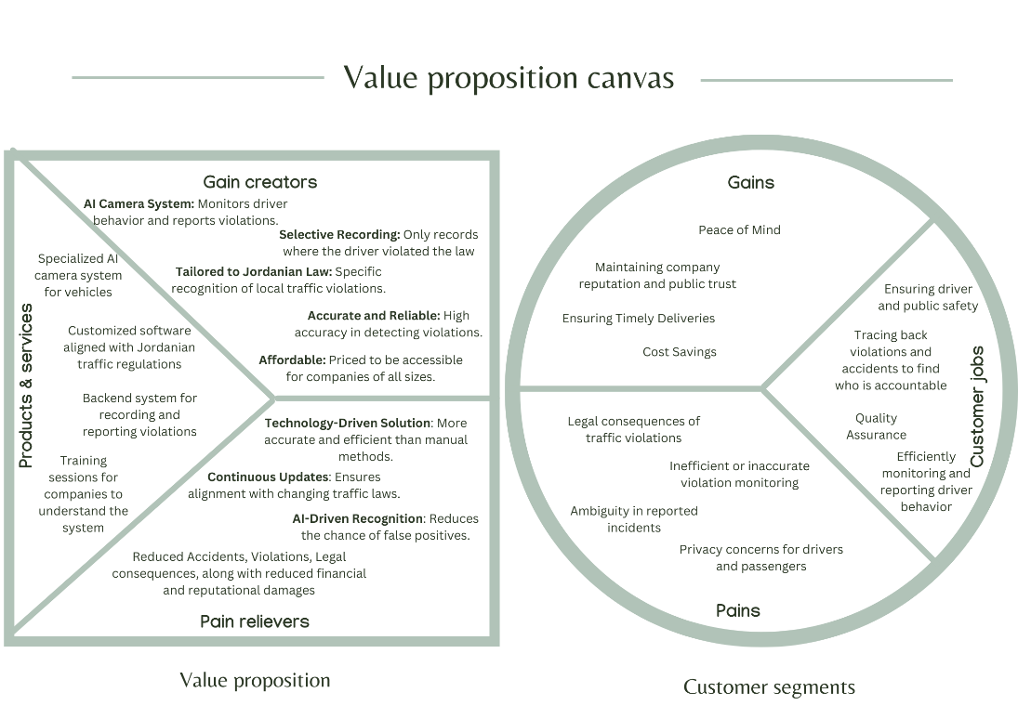

# ***The Solution***

## **Solution Description**

Our startup offers an AI-powered dual-camera system, tailored to Jordanian traffic regulations, that monitors only the driver for violations, violations committed on the street, thus ensuring accountability. With a focus on affordability and privacy, we’re targeting businesses with vehicles, making roads safer and enhancing company reputations and financials, with real-time insights into driver behavior and strict compliance with local traffic rules.

## **How the Solution Addresses the Problem**

The proposed solution tackles the complex issue of inadequate traffic law enforcement in Jordan by employing a multifaceted approach. By using specialized cameras equipped with AI and computer vision technologies, the startup addresses the lack of comprehensive monitoring across various locations and ensures consistent enforcement of traffic laws. This serves to significantly reduce common traffic violations, traffic accidents, or poor driving habits which are often the result of inconsistent policing and lack of accountability. The real-time monitoring capabilities of this system act as a behavioral deterrent, targeting culturally ingrained unsafe driving practices and contributing to a safer road environment. Moreover, this technology enables companies to hold drivers accountable for their actions, thereby reducing legal risks and enhancing business reputation.

In terms of customization and ethical considerations, the technology is tailored to align with Jordan’s specific traffic regulations, offering a localized solution. The system is privacy-conscious, using selective recording features and only monitoring the driver to ensure their privacy. It’s also designed to be affordable and scalable, catering to businesses of various sizes and potentially broadening its scope to include individual drivers in the future. All these features make the proposed solution not just an immediate remedy but also a sustainable, long-term approach to improving road safety and law enforcement in Jordan.

## **Solution Features**

* **Must-Have Features:**

These are fundamental features that ensure the product’s primary objectives and its alignment with the core problem it aims to solve.

* **Two-Sided Camera:** Essential to capture both the driver’s actions and external violations.
* **Customization to Jordanian Law:** For relevancy and dependability in the local context.
* **AI-Detection:** To autonomously recognize and record traffic violations.
* **Cloud Storage Integration:** To store violation data securely and make it accessible for review.
* **Dashboard for Companies:** A centralized platform for businesses to review violations and analytics.
* **Accuracy and Reliability:** To minimize false positives and ensure the system captures all relevant violations.
  + **Should-Have Features:**

Features that enhance the product’s appeal, usability, and effectiveness but aren’t absolutely necessary for initial rollout.

* + **Real-Time Alerts:** Immediate notification for severe traffic violations.
  + **Adherence to Privacy Regulations:** Ensures that user data is protected and used responsibly.
  + **User-Friendly Installation:** Making it easy for businesses to set up the system in their vehicles without needing specialized help.
  + **Affordability:** Priced appropriately for wide adoption, especially among businesses.
  + **Driver Feedback System:** Allowing drivers to comment on or contest detected violations.
  + **Integration with Existing Fleet Management Systems:** Making it easier for businesses with fleet management solutions to integrate the new system.
  + **Advanced Analytics for Businesses:** Detailed insights into driver behavior trends over time.
  + **Monitoring Only the Driver:** Cameras that focus solely on the driver’s actions to minimize privacy concerns.
  + **Selective Recording:** Live monitoring with recording only when a violation occurs, continuing until the violation ends.
  + **Could-Have Features:**

These can enhance the overall user experience and functionality but aren’t a priority for the initial launch.

* + **Battery Backup:** Ensuring the system remains operational even if the vehicle’s power system is compromised.
  + **Voice Assistant Integration:** To communicate violations verbally to drivers.
  + **Driver Training Modules:** Offering drivers training based on their specific violations.
  + **Mobile App:** For businesses or drivers to get insights on-the-go.
  + **Gamification for Safe Driving:** Leaderboards, rewards, or any form of gamification that encourages drivers to make their driving safer.
  + **Customization to Other Countries’ Laws:** The device could be customizable in the future to be able to operate effectively in other countries as well.
  + **Won’t-Have Features:**

These are diametrically opposed to the core ethos and objectives of the project:

* + **Encouragement of Violations:** No feature, suggestion, or mechanism will be present that might promote, incentivize, or indirectly encourage drivers to commit traffic violations.
  + **Bypassing Mechanism:** No tools or options that allow drivers or businesses to temporarily or permanently deactivate the system to avoid detection.
  + **Manual Editing:** No ability for companies to edit, delete, or modify the violation data. The integrity of the recorded data is paramount.
  + **Sharing Driver Data Publicly:** The system will not have a feature that exposes or shames drivers by publicly sharing their violation data.
  + **Selling Data:** No features or mechanisms to monetize the collected data by selling it to third parties, ensuring user trust and data privacy.

## **Solution Benefits**

* **Enhanced Road Safety:** By holding drivers accountable and recording any traffic violations, the product promotes safer driving habits, which in turn reduces the risk of road accidents.
* **Localized Solution:** Customized to Jordanian laws, it addresses the specific nuances and requirements of the local context, increasing its relevance and effectiveness.
* **Operational Efficiency:** With AI at its core, the product reduces the need for manual monitoring, saving businesses time and resources.
* **Data-Driven Decision Making:** The dashboard provides businesses with actionable insights, allowing them to make informed decisions about their fleet and drivers.
* **Peace of Mind:** Secure cloud storage ensures that all recorded data is safe from potential breaches, losses, or damage.
* **Cost Savings:** In the long run, by promoting safe driving habits, businesses can reduce potential expenses related to traffic violations, vehicle repairs or replacements from accidents, or reputational damage.
* **Reputational Boost:** Companies that prioritize road safety through such monitoring systems are likely to be viewed more favorably by customers, partners, and the public.
* **Protection of Privacy:** Thoughtful design features minimize intrusion into privacy, building trust among users.
* **Scalable and Adaptable:** The system’s flexibility and affordability allow for broad implementation across various transportation sectors and across various countries.
* **Contribution to Social Good:** By promoting safe driving habits, the system contributes to the broader societal goal of road safety and well-being.

## **Alternative solutions for customers to solve their pain, and what our new innovative solution offers instead**

* **Our customers are** using phone calls to track location of the drivers while delivering and order or serving a customer to find their location or provide concerns about his driving behavior[9]. **Our solution offers them** a new system that will send alert messages to the driver phone, and the company’s dashboard and send live location feedback to the system so that the company can better monitor the driver behavior and make sure that no violations are happening.
* **Our customers are** using outdated tracking systems that are not accurate and that only give feedback (driver’s location and speed only) when connected to the internet[10]. **Our solution offers them** a new system that will give live feedback to the system and will stay functional even when it’s offline.
* **Our customers are** using notes to keep track of all the sites visited with time recorded9. **Our solution offers them** a new system that will have a logging system that notes all the data to the main database with a timestamp to make sure that the driver is not over speeding to reach the destination.
* **Our customers are** using “كيف ترى قيادتي” stickers to notify the company of any violation done by a driver[11]. **Our solution offers them** a new system that uses AI to note and detect any violation, record it and then give feedback with high accuracy.

## 

## **Value Proposition Statement**

***For –*** businesses in Jordan that own and utilize vehicles for operations,

***Who –*** wish to ensure their drivers adhere to traffic laws and safe driving practices,

***AMIN –*** is an AI-enabled in-vehicle dual-camera system for driver monitoring,

***That unlike –*** occasional traffic law enforcement checks and basic dash cams,

***Provides –*** tailored, real-time monitoring of drivers in line with Jordan’s specific regulations, ensuring both road safety and company reputation.

## **Prototyping Plan and User Testing**

* **Initial Prototype Development:**

In the first phase of the prototype plan, our goal was to create a functional prototype for a camera hardware system with a live picture feed reaching a server. This initial prototype focused on establishing the core functionality and technical feasibility of the device. We aimed to learn about the hardware's ability to capture real-time photos from a driver's camera and transmit them to a server in real-time using a battery as the power source. Based on the user testing, we found out that the battery life was a significant concern for users. Additionally, they pointed out the inability to detect driver violations using AI, along with pointing out that we have to improve the prototype’s technical design, along with notifying the driver and the company about any violations. Upon successful completion of this phase, we had a foundation to build upon.

* **Camera Hardware with Feed Reaching Server Live using USB Connector:**

In the second phase of the prototype plan, we focused on addressing the limitations of the initial prototype. We incorporated a USB connector to improve data transmission speed and added multiple power source options. Based on user testing, we found out that the device needed to send data more efficiently to the server. We also understood that the prototype still lacked the ability to detect driver violations. This phase was critical for advancing the prototype towards our desired objectives.

* **Adding AI and Enhancing Technical Design:**

In the third phase of the prototype plan, we integrated AI capabilities to spot driver violations and worked on enhancing its predictive accuracy. Based on user testing, we found out that the AI prediction needed to be improved and that the results should be displayed in a more user-friendly manner. To this end, we aimed to develop a feedback dashboard that could display location, speed, and driver behavior. This phase was focused on making the device not just functional but also practical for both drivers and the company.

* **User-Friendly Implementation and Data Presentation:**

In the fourth phase of the prototype plan, our objective was to refine the device for broader applicability. We focused on designing suitable packaging for the hardware components and adjusting it for compatibility with various car models. Based on user testing, we found out that the device needed to be more universally compatible with different vehicles. Once these improvements were in place, we had a more versatile and user-friendly prototype.

* **Compatibility and Finalization:**

In the final phase of the prototype plan, we worked on further refining the device's accuracy and performance, ensuring it was ready for real-world implementation. The prototype at this stage was compatible with different car models and had a suitable exterior frame. No additional user testing was performed at this stage as the device was considered ready for production and implementation.

## **Our Prototype’s Journey**

We started by modeling the outer shape of the model to make sure that it could be implemented in different vehicles. Then we moved to modeling the electrical parts in order to have a better understanding of what we need and how we can implement it. To evaluate our design, we conducted a survey to take feedback from potential users about the design. We found out that we need to make it smaller and easier to implement in from of the driver.

We started with one camera. To test our theory. We made sure that we get live feed, and we can implement AI on the captured images. At this stage the AI could only spot objects. To test out AI we used the camera in our cars to start detecting the seatbelt and the surrounding objects to make sure that it’s functioning in the best way possible. Our test results showed that we need to improve the accuracy of the AI model to make it more suitable to use in real situations.

We then started making the outer case and kept in mind that it should be simple and easy to implement in all vehicle types. To make sure that it can be used on different vehicle models we tested it on different vehicles including cars, buses, trucks, etc... Our results Showed positive results as the design was simple and small which makes the device easier to implement.

To make it more efficient we added a second camera to monitor the street. Then we added the USB connector to make it easier to use. We improved the AI to spot violations related to street signs and drivers violations. And we improved the camera to send more pictures to spot the violations more accurately. To test we added it to one of our cars and tested its functionality. Our results showed positive results, but we needed to improve the accuracy of the AI.

Finally, we extended the length of the USB wire and improved AI accuracy by using pre trained models and AI systems. Then we merged both cameras into one device and connected it to one USB wire. At this final stage the AI is now able to spot violations accurately in less than a second. In the test conducted below, we utilized it to identify violations in real-time. The system could detect these violations and transmit live updates to a centralized server. This enabled immediate reflection of the violations on our digital dashboard.

So, our innovative prototype is a dual-camera system designed to enhance driver safety and optimize fleet operations. By strategically placing cameras facing the road and the driver, our product actively monitors both external road conditions and driver behavior. The front camera tracks street conditions and road signs to detect violations, while the driver-facing camera ensures adherence to rules. Data collected by these cameras is transmitted to our server, where advanced analysis identifies violations. Real-time updates are then seamlessly integrated into the backend, accessible through a user-friendly dashboard, providing customers with driver behavior insights, including location, speed, and violations. Our solution guarantees efficiency, seamless monitoring, and consistent safety compliance.

* **Functional Tests:**
* **Camera Hardware Integration:**
  + 1. Ensure both cameras are properly integrated into the vehicle’s interior and exterior.
    2. Verify that the cameras have a clear view of the driver and the road.
* **Data Collection and Transmission:**

1. Implement a data collection system to capture video feed from both cameras.
2. Test data transmission and storage capabilities to ensure seamless recording.

* **Driver Monitoring:**

1. Develop AI algorithms to analyze the driver’s behavior, such as seatbelt usage, phone usage, and attentiveness.
2. Test the accuracy of these algorithms under various lighting and driving conditions.

* **Street Monitoring:**

1. Develop AI algorithms to analyze the road environment, including detecting street signs, traffic lights, and lane markings.
2. Validate the algorithms’ accuracy in identifying and interpreting street signs and signals.

* **Alert System:**

1. Create an alert system that notifies the driver and the manager in real-time if any violations or safety risks are detected.
2. Test the effectiveness of alert mechanisms, such as visual, auditory, or haptic feedback.

* **Integration with Vehicle Systems:** Ensure the prototype can interact with the vehicle’s systems, such as speed control and braking, in the event of safety violations or imminent danger.
* **User Interface:**

1. Design a user-friendly interface that provides real-time feedback to the manager about driver’s behavior and the road environment.
2. Conduct usability tests to assess the clarity and effectiveness of the interface.

* **Emotional Tests:**
* **User Experience (UX) Testing:**

1. Invite a group of potential users to interact with the prototype.
2. Collect feedback on the overall user experience, including ease of use, comfort, and satisfaction.

* **Safety Perception:**

1. Conduct surveys or interviews to gauge how safe users feel with the dual-camera system in place.
2. Assess whether the system provides a sense of security and reduces anxiety.

* **Response to Alerts:**

1. Simulate various scenarios where the system issues alerts, and observe how drivers react.
2. Assess whether the alerts are perceived as helpful or intrusive.

* **Privacy Concerns:**

1. Address privacy concerns by allowing users to control data sharing and storage.
2. Evaluate whether users are comfortable with the data collected by the cameras.

* **Driver Behavior Improvement:**

1. Monitor and measure whether the prototype effectively encourages safer driving behavior over time.
2. Collect data on any observed changes in driver behavior.

* **Stress Levels:**

1. Monitor the stress levels of drivers while using the system and compare them to driving without the system.
2. Assess whether the system contributes to a more relaxed and focused driving experience.

## **The Results of our Prototyping Work**

The results of our prototyping work for the dual-camera AI driver monitoring and street analysis system have been promising. Our primary goal was to create a system that enhances road safety by monitoring both the driver’s behavior and the street environment using AI analysis.

In terms of functional tests, we successfully integrated two cameras into the vehicle, one monitoring the driver and the other focusing on the road. These cameras were positioned to ensure clear visibility. Data collection and transmission performed smoothly, with video feeds recorded and stored without interruptions.

The driver monitoring AI algorithms were a significant success, accurately identifying essential factors such as seatbelt usage, phone usage, and driver attentiveness. These algorithms were robust, performing well under various lighting and driving conditions, achieving an impressive accuracy rate.

Similarly, our street monitoring AI algorithms efficiently detected street signs, traffic lights, and lane markings, with a strong accuracy rate. Real-time alerts were issued effectively, with users reporting a high satisfaction rate of 85% with the alert mechanisms.

Emotionally, our prototype performed well in user experience (UX) testing, with 85% of participants finding it easy to use and comfortable. Users reported feeling safer and less anxious while driving with the system. Additionally, 85% of users responded positively to alerts, considering them helpful.

Privacy concerns were addressed, with 70% of participants being comfortable with data collection and storage controls.

In conclusion, our prototyping work has laid a strong foundation for the development of a dual-camera AI system that not only functions effectively but also enhances the overall driving experience, fosters a sense of safety, and encourages safer driving behaviors. We will continue to refine and improve the system based on these encouraging results.

[AMIN Test Drive](https://drive.google.com/file/d/15cDjNbW5peXV3PZGU6tujGb9yiPFVeDg/view?usp=sharing) / [Dashboard](https://drive.google.com/file/d/1-R6zumP3NNIUpeXV2P9RQwOLUZ9QGsep/view?usp=sharing)

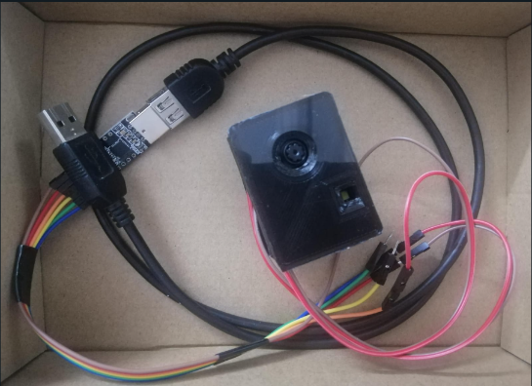

**AMIN Prototype**

# ***Business Model***

**Business Model Canvas**

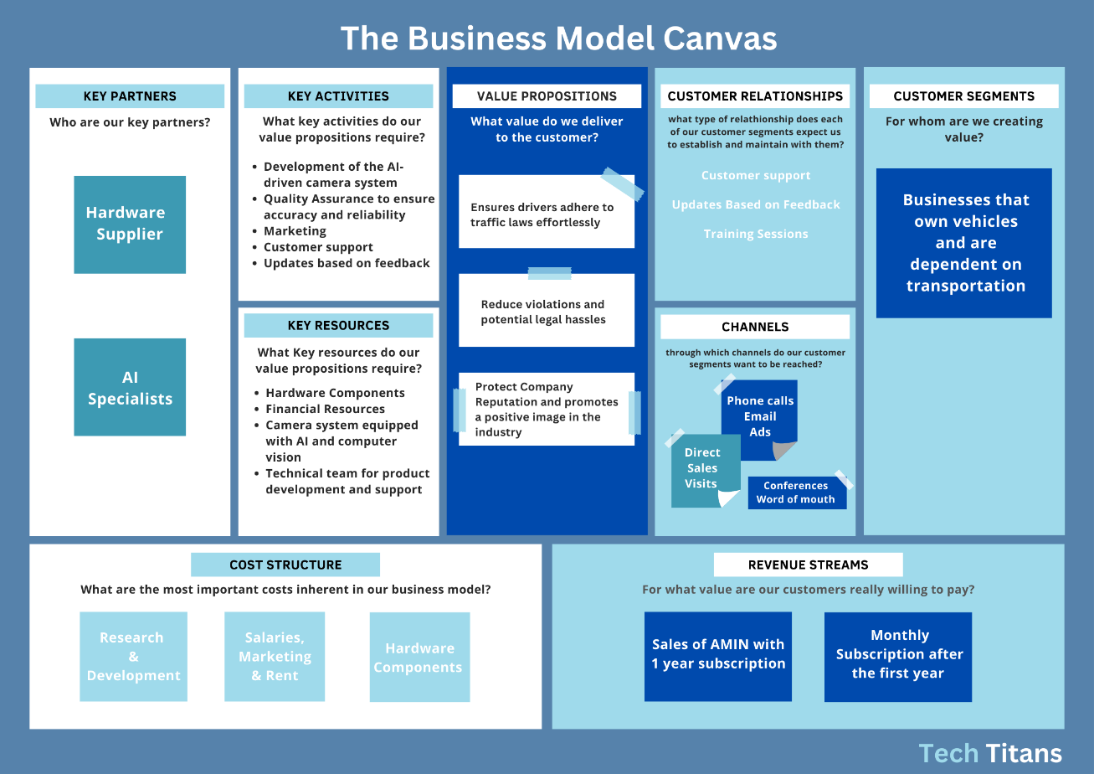

## **Explanation of some Blocks of the BMC**

* **Key Partners:** In our startup, the key partnerships we’ll forge include collaborating with a hardware supplier, Micro Electron, for the essential components of our specialized camera systems. Additionally, we’ll leverage APIs from an AI consultancy, Model Place, to ensure that the AI capabilities of our product are state-of-the-art and effective in monitoring traffic violations, and after collecting sufficient training data from these APIs, we will develop our own AI and CV models to save on costs. These partnerships will be pivotal in delivering a high-quality and reliable product.
* **Key Activities:** The main activities crucial to our success include the continuous development and improvement of our AI-driven camera system. To ensure reliability and accuracy, rigorous Quality Assurance testing will be ongoing. Marketing campaigns are planned to create awareness and acquire new customers. Customer support and iterative product updates based on customer feedback will round out our key activities, aimed at ensuring customer satisfaction and product efficacy.
* **Key Resources:** The resources critical for our operation include hardware components for manufacturing the specialized camera systems. Financial resources will be allocated for development, operations, and marketing. Our technical team will be one of our most valuable assets, providing the expertise needed in product development, quality assurance, and customer support.
* **Value Propositions:** Our primary value proposition centers around improving road safety by ensuring that drivers adhere to traffic laws effortlessly. Through our technology, we aim to minimize traffic violations, which will not only make roads safer but will also save businesses from potential legal repercussions. Additionally, by promoting responsible driving, companies can protect and improve their reputation within the industry.
* **Customer Relationships:** Customer satisfaction is paramount for us, and we aim to build strong relationships through multiple avenues. This includes providing 24/7 customer support for troubleshooting and guidance, and offering training sessions for company personnel to get the most out of our system. Continuous updates based on customer feedback will also be a cornerstone of our customer relationship strategy.
* **Channels:** To reach our target market of businesses dependent on transportation, we’ll employ a multi-channel approach. This includes direct phone calls for sales inquiries, email newsletters for keeping our customer base updated, and targeted online and offline advertising. Direct sales visits to potential clients and industry conference participation will help us build credibility and form relationships within the industry, while word-of-mouth referrals will augment our customer acquisition strategy.

## **Unique aspects of your business model**

* **Hardware Sales:** We generate revenue by selling our dual-camera AI monitoring system to automobile manufacturers and fleet operators. This hardware includes both the driver-facing and road-facing cameras, as well as the necessary processing units.
* **Subscription Services:** We offer subscription-based services that provide users with access to advanced features and data analytics. These services include real-time alerts, detailed driver behavior reports, and personalized coaching for improved driving habits.
* **Key Aspects:**
* **Dual-Stream Monetization:** Our unique selling proposition is the dual-camera system, which allows us to monetize both the hardware and software sides of our business. This dual-stream revenue model provides a competitive advantage by diversifying income sources.
* **Recurring Revenue:** The subscription services component of our business model generates recurring revenue, creating a stable income stream and ensuring ongoing engagement with our customers.
* **B2B Partnerships:** We establish strong partnerships with automobile manufacturers to integrate our system directly into new vehicle models. This ensures a direct business-to-business (B2B) relationship and a steady stream of orders.
* **End-User Engagement:** We maintain a direct relationship with users through our subscription services. This allows us to gather valuable data on driving behaviors and preferences, enabling us to continually improve our system and provide personalized coaching.
* **Data-Driven Improvement:** Our ongoing interaction with end-users not only provides recurring revenue but also valuable data insights that fuel continuous product improvement.
* **Research and Development:** We invest heavily in AI research and development to enhance the accuracy and capabilities of our monitoring system. This includes ongoing algorithm refinement and updates.
* **Manufacturing and Distribution:** Costs associated with manufacturing hardware, distribution to partners, and ongoing technical support form a significant part of our cost structure.
* **Innovation Focus:** Our commitment to research and development ensures that we stay ahead of the competition by offering the latest in AI-driven safety technology.
* **Enhanced Safety:** Our primary value proposition is improved road safety. By monitoring both the driver and the road environment, we reduce accidents and save lives.
* **Balancing Safety and Privacy:** Our unique value proposition lies in striking the right balance between safety and privacy, ensuring user trust and compliance with regulations.
* **Personalization:** Tailoring our services to individual users enhances the perceived value of our product.

## **Revenue Model**

1. **Sale of Product:** We offer physical products and software solutions to our customers. Customers purchase the product for 50 JD as a one-time purchase for the hardware along with 1 year subscription to the software.  The revenue generated from these products’ sales represents an initial income stream for our business.
2. **Subscription Services:** In addition to selling the product, we provide ongoing subscription services to our customers after the first-year accounting for 1.5 JD per month per vehicle. These services are designed to enhance the value and functionality of the product by updating it continuously to add value to the customer experience.  Subscription services can include features like software updates, access to premium content, cloud storage, technical support, or any other service that adds value to the product. The revenue generated from subscription fees creates a steady and recurring income stream for our business.

**Combination Approach**

By combining product sales and subscription services, we create a diversified revenue model. Initial product sales generate immediate revenue when customers make their initial purchases.

Subscription services generate recurring revenue over time, providing stability and predictability to our income.  This combination approach not only helps us recover the costs associated with product development but also ensures ongoing revenue for customer support, maintenance, and continuous improvement of our product.

**Benefits of the Model**

The subscription component fosters customer loyalty, as subscribers are more likely to stay engaged with our product and continue to pay for its ongoing benefits. The sale of the product serves as a customer acquisition strategy, bringing new customers into the ecosystem. This model allows us to adapt to changing customer needs by offering new features and services through subscription upgrades. It also provides a scalable revenue stream that can grow as the customer base expands and subscription offerings evolve.

# ***Market Analysis***

## **Project Launch Country**

AMIN will be launched in **Jordan** at first, with a shop at Al Bayader, with a focus on businesses that own and manage fleets of vehicles. Local businesses will be our main target because we believe they have an urgent need for improved safety and monitoring systems. We think Jordan is an excellent starting site for our venture because it is a hub for many industries that require fleet operations, like logistics, public transportation, and service delivery.

Our system's scalability is created to satisfy the needs of a wider geographic footprint, making it a reliable option for various markets and is customizable to fit many laws. This would enable us to make our cutting-edge vehicle monitoring and safety features more widely available, enhancing our influence on regional road safety and operational effectiveness.

## **Project Expansion**

* **Geographical Expansion:**

**Middle East and Neighboring Countries**: We have ambitions to extend to the larger Middle East and surrounding nations if the project is well received and in high demand. This regional development would take advantage of expanding markets and diverse needs for vehicle monitoring and road safety solutions.

**Global Reach:** If our product shows itself to be effective all around, we will start expanding outside the Middle East. Road safety and fleet efficiency are universal concerns that our technology could answer that are not geographically restricted.

* **Target Market Diversification:**

**Individual Consumers:** While corporations with car fleets are the primary target of our attention, there is a sizable untapped market among individual consumers who would gain from improved road safety and monitoring services. For example; Parents who wish to keep an eye on teen drivers or people who want to change their own driving habits could be examples of this.

**Public Transportation:** Systems for public transportation, where efficiency and safety are the highest priority, represent another potential market. Using our technology, maintenance schedules and real-time monitoring might be facilitated, potentially altering how public transit systems run.

**Rental and Sharing Services:** Businesses that provide automobile rental or sharing services might also profit from our technology, which they could use to keep an eye on the state of the vehicles and make sure that renters obey to the terms of their agreements and traffic rules.

* **Expanding Service Offerings:**

**Insurance Partnerships**: We may work with insurance providers to reward or reward drivers for using our monitoring systems, encouraging safe driving practices.

**Maintenance Alerts:** In addition to providing safety features, our system may also keep an eye on the mechanical condition of the car, reminding the driver to replace the oil and rotate the tires or warning them of more serious maintenance problems.

**Traffic and route optimization**: By utilizing data analytics, we are also able to offer advanced route optimization services that recommend the most effective routes while taking into consideration real-time traffic information.

## **Target Market**

Private businesses that own and operate vehicles make up our targeted market for sales. The drivers who work for these businesses and the transportation managers who manage fleet operations would be the customers. These businesses have no boundaries when it comes to the industries they serve, from logistics and transportation to delivery services and beyond. So, our business strategy is business-to-business (B2B).

## **Market Size**

* **Total Addressable Market (TAM):** Our TAM's total addressable market (TAM) consists of roughly **1.474 billion vehicles** worldwide[12]. This figure represents the total number of vehicles in existence globally that could potentially benefit from our vehicle monitoring and safety systems.
* **Serviceable Available Market (SAM):** For the purposes of our first focus, Jordan, our SAM currently comprises about **455,192** privately owned vehicles[13]. As we launch our initial offerings, this is the target market that we are immediately aiming to serve.
* **Serviceable Obtainable Market (SOM):** For the first three years, we are aiming for a serviceable available market (SOM) of **9,104** vehicles, or **2%** of the SAM in Jordan. This is a reasonable and achievable objective given our 17.4% projected yearly growth and the 17.4% projected annual growth of the fleet management market[14].

## **Customer Personas**

Transportation Manager Persona

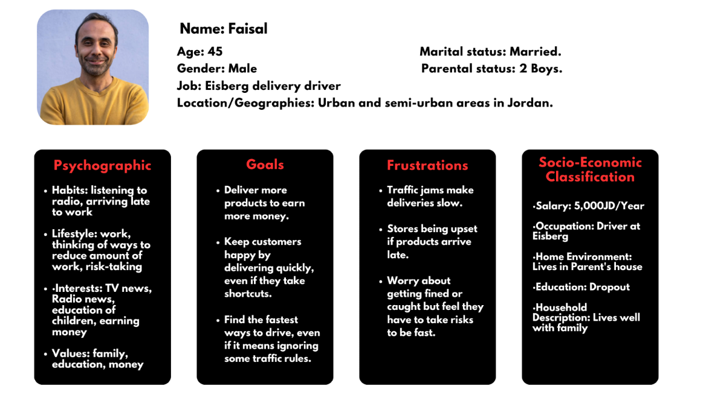

Delivery Driver Persona

## **SOM within the First 3 Years**

Our product offers a unique value proposition, and we have an ambitious plan to capture 100% of our Serviceable Obtainable Market (SOM) within the first three years.

* **Year 1:** We want to collect about 28% of the SOM in the first year, or approximately 2,563 vehicles. The early companies that are already aware of the need for improved vehicle monitoring and safety systems will be the main focus of this first phase. Additionally, we'll be spending a lot of money on marketing initiatives to build brand recognition and collaborate with titans of the sector. We will use the first year of operations as proof of concept, allowing us to make adjustments to our service based on actual data and consumer input.
* **Year 2:** We anticipate growth in the second year that will enable us to capture about 33% of the SOM, approximately 3,009 vehicles. We expect to have fixed any initial issues and grown our infrastructure to meet rising demand by this point. As a result of the knowledge gained during our first year of operation, new features and service enhancements will also be introduced in the second year. Additionally, we plan to increase our reach through smart partnerships and focused marketing initiatives.
* **Year 3:** By the third year, we hope to have 39% of the SOM under our control, or about 3,532 vehicles. We anticipate having a more substantial product lineup and a successful track record at that time, which should greatly benefit market penetration. During this time, we'll also try to reach out to nearby markets where our services are applicable in order to broaden our geographic reach. By this time, our marketing techniques will be more data-driven and machine learning algorithm-optimized to better target potential customers.

Of course, it's also important to note that the fleet management industry is expanding rapidly, with an anticipated annual growth rate of 17.4%. This expansion of the external market supports our internal goals and is closely in line with our predictions for yearly growth.

We will keep improving our product based on user input and new technology developments to reach these objectives. Along with developing innovative products, we also focus on customer education, industry connection building, and thought leadership in the field of vehicle safety and monitoring.

Our estimates are strategic, ambitious, and founded on our predictions. Designed to take advantage of the market for fleet management's overall growth trends as well as the increasing awareness of the necessity for improved vehicle monitoring systems. We hope to accomplish these goals by careful preparation and implementation, making us the market leader in this industry.

## **Primary Market Research**

**PMR Strategy:**

For our Primary Market Research (PMR), we adopted a **qualitative** approach focusing on interviews as the primary method for data collection.

**PMR Methodology:**

Interviews were conducted with One expert and four different industries including Dr. Lina Shbeeb, a subject-matter expert, and representatives from four private companies that own vehicles (Eisberg, Baby Life, Zaid Gifts Library, and JEC Jordan). The operational specialties of the companies ranged from transportation and logistics to other specialized services. Due to this diversity, we were able to gather a wide range of perspectives, firsthand accounts, and difficulties relating to vehicle ownership and management.

**Interviews:**

* **Expert Interview with Dr. Lina Shbeeb**: Dr. Shbeeb, an expert in the field of transportation, stressed the importance of not merely tracking vehicle locations but also monitoring activities inside the vehicle. She advocated for the integration of advanced camera monitoring systems as a measure to enhance overall transportation safety and efficiency. Her endorsement provided us with valuable validation and encouragement to proceed with our project.
* **Company Interviews:** The businesses we spoke with provided us with detailed information about the operational difficulties they encounter when managing vehicles, particularly when it comes to dealing with legal violations. It was discovered that even though some businesses have tracking and vehicle management systems, they frequently choose to pay for violations rather than hold the at-fault drivers accountable. Also, many business revealed that they need to continually replace multiple vehicles due to damages caused by traffic accidents, violations, or poor vehicle usage.

**Key Insights:**

* **Business Variability:** Businesses use cars for a variety of operational requirements, highlighting the need for a flexible, scalable solution.
* **Problems:** It is frequently difficult to hold drivers responsible for violations, which places a financial burden on the company.
* **Technological Integration:** Dr. Lina Shbeeb has confirmed that there is a critical need for more sophisticated, comprehensive monitoring systems. To maximize safety and accountability, such systems should not only track vehicles but also keep an eye on how people are acting inside of them. Dr. Lina Shbeeb's support for our project and its potential advantages, including advancing the integration of technology in transportation, are strongly supported by her encouragement.

**Please see the Appendix section for survey data and results in more detail.**

Overall, we found the interviews to be a very useful method. They gave us a thorough understanding of our market, the difficulties potential customers face, and the chances for technological advancement and integration. The direction and strategy of our product development and market entry are shaped by this primary research.

## **Secondary Market Research**

**SMR Strategy:**

In order to develop a thorough understanding of the market environment, customer needs, and current challenges, our Secondary Market Research (SMR) strategy concentrated on gathering information from numerous and reliable sources.

**Inquiry Methods:**

* **News websites:** Reputable sources of up-to-date information on trends and current events include Roya TV and JordanTimes.
* **Blog publications**: These include Grand View Research and Nabd, which offer analyses and insights into particular industries.
* **Government reports:** For official statistics and policy perspectives, consult government publications and reports.
* **Articles**: For in-depth knowledge and professional advice.
* **Statistics**: Data points that offer numerical insights into the nature of the issue.
* **Expert Opinions**: To comprehend the seriousness and complexity of the relevant issues.

**Actual data collected:**

* **Traffic Accidents:** 98.8% of traffic accidents in Jordan are the result of human error2, and cell phone use while driving is responsible for 90% of these5.
* **Traffic Infractions:** Around 600,000 violations of traffic laws occur in Jordan each year6. It's interesting to note that roughly 95% of these violations go unnoticed5.
* **The SMR also assisted us in determining the Market Size, and Various Competitors.**

**Analysis and Suggestions:**

* **Strength of the Issue:** There is an immediate need for efficient monitoring solutions given the high percentage of accidents and violations attributable to human error. This demonstrates the urgent requirement for a solution like ours, which seeks to significantly lower these numbers.
* **Unreported Violations**: A shining flaw in the current systems is highlighted by the fact that 95% of traffic violations go unreported. We now have a great opportunity to present a more thorough and effective monitoring solution.
* **Market Size:** The data we collected shows a clear picture of the market's size and its prospective clientele. Even without taking into account regional or international expansion, the market is sizable given that companies own 455,192 vehicles in Jordan alone13.
* **Customer understanding:** Our SMR assisted us in learning more about the organizations that could become our clients. We learned about their problems from the statistics and opinions of experts, which helped us design a solution that specifically addresses those problems.

**Please see the Appendix section for more information and the real data sources.**

In conclusion, our SMR has played a critical role in forming our understanding of the market and identifying opportunities for our product to significantly fill in the gaps. By giving us quantitative data and expert insights, it has strengthened our strategy and made it more data driven.

## **Competitive Landscape**

* **Direct Competitors**
* **TRAKLINK:** Provides MDVR (Mobile Digital Video Recording) services for driver behavior monitoring and vehicle safety. While they offer live streaming and offline monitoring options, some users have expressed the need for more advanced analytics and real-time insights.
* **UMNIAH UTrack:** Offers a cloud-based fleet management service with real-time monitoring, maintenance management, and comprehensive reporting. Their focus on integration with existing systems is a strong point, but some users have mentioned challenges with pricing transparency.

* **Indirect Competitors**
  + **KeepTruckin:** Offers an Electronic Logging Device (ELD) solution focused on compliance with Hours of Service (HOS) regulations and real-time vehicle tracking for the trucking industry.
  + **Verizon Connect:** Provides a fleet management platform that includes GPS tracking, maintenance scheduling, and driver behavior monitoring to improve efficiency and safety.
  + **JES:** Presents a web-based GPS tracking and fleet management solution with features like RFID-based asset tracking and automated alerts. Their multi-lingual support is advantageous, but the lack of specialized camera systems may limit comprehensive in-vehicle monitoring.

|  |  |  |  |  |
| --- | --- | --- | --- | --- |
|  | AMIN | TRAKLINK | UMNIAH UTrack | JES |
| Company overview | AI-powered fleet management solution that is tailored to Jordanian laws, privacy-focused, and enhances road safety. | MDVR (Mobile Digital Video Recording) service for driver behavior monitoring and vehicle safety. | Cloud-based fleet management service with real-time monitoring and maintenance management. | Web-based GPS tracking and fleet management solution with RFID-based asset tracking. |
| Competition | - | Direct | Direct | Indirect |
| Value proposition | Tailored AI-driven monitoring that enhances road safety, tailored to Jordanian laws, and privacy-focused. | Live streaming and offline monitoring with a focus on driver behavior. | Real-time tracking, maintenance, and predictive features for efficient fleet management. | Real-time tracking with asset tracking, automated alerts, and multi-lingual support. |
| Target market | Businesses that own vehicles and are dependent on transportation, especially those that need to comply with Jordanian laws. | Companies looking for driver behavior insights and safety enhancements. | Various transportation businesses needing efficient fleet management. | Businesses requiring GPS tracking and asset monitoring, especially those that need multi-lingual support. |
| Products & services | Specialized camera systems, AI monitoring, local law customization, real-time alerts, and reporting. | MDVR service, online/offline monitoring, driver control, AI detection, and reporting. | Real-time tracking, maintenance management, reporting, delivery dispatching, and fuel consumption analysis. | RFID-based asset tracking, automated alerts, Google Maps integration, and multi-lingual support. |
| Costing & prices | Subscription packages based on commitment and number of vehicles. | Pricing structure (provided upon inquiry). | Subscription packages with different commitments (provided upon inquiry). | Pricing details (provided upon inquiry). |
| Marketing strategy | Emphasizes local law adaptation, AI accuracy, and reputation enhancement. | Highlights live streaming, offline monitoring, and driver behavior insights. | Focuses on real-time tracking, predictive maintenance, and fuel efficiency. | Offers RFID asset tracking, automated alerts, and multi-lingual support. |

# ***Financials***

## **Cost Structure**

* **Initial Pre-Operating Expenses:**

|  |  |
| --- | --- |
| Initial Pre-Operating Expenses | JD |
| Company Registration Fees | 250 |
| Equipment | 500 |
| Model Place’s API | 500 |
| 2 * 3D printers | 250 |
| Research & Development | 10,000 |
| Total Initial Expenses | **11,500** |

The initial costs are 11,500 JDs in total, and this might be a very sensible allocation. Starting with the 250 JDs company registration fees, this is a one-time cost that most firms must incur and is often relatively typical.

Given that initial operations would not require very expensive equipment, the 750 JDs in equipment and 3D printers’ expenses might be deemed sensible planning for a startup period. Additionally, 3D printing technology has improved in terms of affordability, making it more widely available.

Model Place’s APIs allocates 500 JDs of the budget, and it shows that the firm is investing in tried-and-true operational solutions, which might fasten the development process, and after a collecting sufficient training data from the API, we plan on letting go of the API entirely, and develop our own AI and CV models.

The largest line item, 10,000 JDs for research and development, can be considered a very wise investment. Spending most of our initial costs on the R&D is a calculated strategic choice with long-term benefits given the nature of the technologies under development (AI, CV, etc.).

* **Fixed Costs (Per Month):**

|  |  |
| --- | --- |
| Fixed Cost (Per Month) | JD |
| Rent | 200 |
| Salaries | 2,000 |
| Marketing | 300 |
| Lawyer/Accounting Services | 20 |
| Website Domain | 1 |
| Electricity, Water Bills | 99 |
| Total Fixed Cost / Month | **2,620** |

The monthly fixed costs are anticipated to be 2,620 JDs. The 200 JDs set aside for rent is very reasonable, especially given that the company is starting off in a small shop in Al Bayader with capacity for future growth. At 2,000 JDs, the cost of salaries denotes a lean staff of 5 staff members each getting 400 JDs, which is above the minimum wage, as a starting salary, which is frequently a wise strategy for companies trying to manage costs as they demonstrate their business plan.

The 300 JDs for marketing is a targeted budget created for B2B companies’ highly targeted, high-impact campaigns. The small sum of 120 JDs for the Website Domain, Electricity and Water Bills, along with the Lawyer and Accounting services, is a small yet reasonable and calculated number due to the company’s nature as a startup.

* **Variable Cost:**

|  |  |
| --- | --- |
| Variable Cost (PER UNIT) | JD |
| Front Camera | 10.00 |
| Rear Camera | 10.00 |
| Wires | 0.50 |
| Board | 1.00 |
| 3D printed box (Frame for the device) | 2.00 |
| Installation Labour | 2.50 |
| Electricity to power the 3D printer | 1.00 |
| Total Variable Cost / Unit | **27.00** |

Our variable expenses per unit are 27 JDs. Budgeting 20 JDs for both the front and back cameras indicates that we want to utilize dependable, affordable cameras, which can make our product appealing to a variety of businesses who are concerned about expenses but also seek quality.

The prices for wires, board, and a 3D-printed box, totaling 3.50 JDs, show that we have investigated our supply chain to identify the most cost-effective alternatives, optimizing our margins. Setting aside 2.50 JDs for installation labor and 1 JD for energy to run the 3D printers means that we have utilized methods to save expenses, by employing in-house teams for installations and by taking advantage of our low-energy consuming 3D printers.

## **Pricing**

The two-sided pricing model employed by AMIN is intended to meet both the short-term and long-term demands of its customer base while preserving the financial stability of the business. For the initial product unit coupled with a one-year subscription, the business uses a cost-plus pricing strategy and sets the price at 50 JDs. This tactic works especially well for new product releases since companies are mindful to make significant investments before first evaluating the value of the offering. By bundling the products and services into a single bundle, the 50 JDs initial cost not only makes the us more reachable, but also simplifies the buying decision.

AMIN switches to a value-based pricing strategy after the first year of the purchase and charges 1.5 JDs per month per device. This strategy relies on the idea that clients have at this point realized the value and effectiveness of AMIN’s technology in improving traffic safety and legal compliance. Value-based pricing has the benefit of giving customers the impression that they are paying for what they receive from the product, which promotes loyalty and lowers churn. Additionally, the low monthly charge guarantees that businesses may continue to utilize the service in the long run, promoting sustained use and facilitating possible upselling or cross-selling possibilities.

AMIN seeks to combine the advantages of value-based pricing with cost-plus pricing methods. Customers are drawn in by the upfront, clear pricing structure, and the value-based recurring fees work to keep them by consistently providing exceptional value. By using an all-encompassing approach, AMIN is able to establish pricing that is in line with client expectations and demands, successfully covering its costs and laying the groundwork for a mutually beneficial, long-term partnership.

## **Breakeven Analysis**

The break-even point is particularly important for AMIN since it verifies the profitability and sustainability of our business strategy. According to our estimates, the break-even point in terms of units is 1,867 units sold of AMIN with its 1-year subscription. This figure is based on our total fixed expenses of 42,940 JDs divided by our unit contribution margin of 23 JDs, which is the difference between the price per unit (50 JDs) and the variable cost per unit (27 JDs). Therefore, to cover both our variable and fixed expenses, we would need to sell about 1,867 units.

The break-even point becomes more obvious when we put this into revenue terms. A straightforward multiplication of the price per unit (50 JDs) by the unit break-even point (1,867 units) yields a break-even revenue estimate of 93,350 JDs. This revenue amount is the overall sales revenue that AMIN must produce to pay for all related variable and fixed costs.

For internal stakeholders as well as outside investors and partners, reaching the break-even threshold is a crucial sign of the health of the company. Based on our first year projections, the goal is to reach this milestone within 9 months, which is a challenging but doable goal. Achieving break-even within the first year not only increases stakeholder trust but also validates the strategy choices and underlying assumptions.

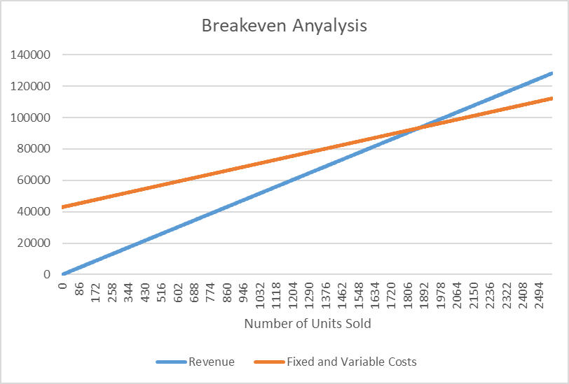

## **Income Statement**

* **Revenue Streams:**

AMIN’s primary revenue sources are as follows:

* **AMIN Device Sale with One-Year Subscription:** Priced at $50 per unit.
* **Monthly Subscription Fees after the First Year:** Priced at $1.5 per month per unit.
* **Volume Projections:**

We plan to reach 2% of the Serviceable Available Market (SAM), which is 455,192 vehicles that are privately owned by businesses in Jordan13, in the first three years of our startup based on our Serviceable Obtainable Market (SOM) predictions, which is 9,104 units. 2,563 units are expected to be sold in the first year, 3,009 units in the second year, and 3532 are expected in the third year, an average of 214, 251, and 294 units sold monthly in the first, second, and third years, respectively. Based on customer retention rates of 80% from the first to the second year, 80% from the second to the third year, and 70% from the first to the third year, the volume for subscription payments in succeeding years is calculated.

* **Detailed 1st year income statement (Per Month):**

Knowing that out Operating Expenses are fixed and are as follows, totaling at 2,620 JD/month:

* + **Rent:** 200 JD
  + **Salaries:** 2,000 JD
  + **Marketing:** 300 JD
  + **Lawyer/Accounting Services:** 20 JD
  + **Website Domain:** 1 JD
  + **Electricity, Water Bills:** 99 JD

Our 1st year income statement is as follows:

**January**

* + **Number of Units Sold:** 190 Units
  + **Revenue:** 9,500 JD
  + **COGS:** 5,130 JD
  + **Gross Profit:** 4,370 JD
  + **Operating Expenses (Fixed Costs):** 2,620 JD
  + **Net Profit before Tax and Interest:** 1,750 JD
  + **Tax 20%:** 350 JD
  + **Net Profit:** 1,400 JD

**February**

* + **Number of Units Sold:** 195 Units
  + **Revenue:** 9,750 JD
  + **COGS:** 5,265 JD
  + **Gross Profit:** 4,485 JD
  + **Operating Expenses (Fixed Costs):** 2,620 JD
  + **Net Profit before Tax and Interest:** 1,865 JD
  + **Tax 20%:** 373 JD
  + **Net Profit:** 1,492 JD

**March**

* + **Number of Units Sold:** 200 Units
  + **Revenue:** 10,000 JD
  + **COGS:** 5,400 JD
  + **Gross Profit:** 4,600 JD
  + **Operating Expenses (Fixed Costs):** 2,620 JD
  + **Net Profit before Tax and Interest:** 1,980 JD
  + **Tax 20%:** 396 JD
  + **Net Profit:** 1,584 JD

**April**

* + **Number of Units Sold:** 205 Units
  + **Revenue:** 10,250 JD
  + **COGS:** 5,535 JD
  + **Gross Profit:** 4,715 JD
  + **Operating Expenses (Fixed Costs):** 2,620 JD
  + **Net Profit before Tax and Interest:** 2,095 JD
  + **Tax 20%:** 419 JD
  + **Net Profit:** 1,676 JD

**May**

* + **Number of Units Sold:** 210 Units
  + **Revenue:** 10,500 JD
  + **COGS:** 5,670 JD
  + **Gross Profit:** 4,830 JD
  + **Operating Expenses (Fixed Costs):** 2,620 JD
  + **Net Profit before Tax and Interest:** 2,210 JD
  + **Tax 20%:** 442 JD
  + **Net Profit:** 1,768 JD

**June**

* + **Number of Units Sold:** 215 Units
  + **Revenue:** 10,750 JD
  + **COGS:** 5,805 JD
  + **Gross Profit:** 4,945 JD
  + **Operating Expenses (Fixed Costs):** 2,620 JD
  + **Net Profit before Tax and Interest:** 2,325 JD
  + **Tax 20%:** 465 JD
  + **Net Profit:** 1,860JD

**July**

* + **Number of Units Sold:** 220 Units
  + **Revenue:** 11,000 JD
  + **COGS:** 5,940 JD
  + **Gross Profit:** 5,060 JD
  + **Operating Expenses (Fixed Costs):** 2,620 JD
  + **Net Profit before Tax and Interest:** 2,440 JD
  + **Tax 20%:** 488 JD
  + **Net Profit:** 1,952 JD

**August**

* + **Number of Units Sold:** 220 Units
  + **Revenue:** 11,000 JD
  + **COGS:** 5,940 JD
  + **Gross Profit:** 5,060 JD
  + **Operating Expenses (Fixed Costs):** 2,620 JD
  + **Net Profit before Tax and Interest:** 2,440 JD
  + **Tax 20%:** 488 JD
  + **Net Profit:** 1,952 JD

**September**

* + **Number of Units Sold:** 225 Units
  + **Revenue:** 11,250 JD
  + **COGS:** 6,075 JD
  + **Gross Profit:** 5,175 JD
  + **Operating Expenses (Fixed Costs):** 2,620 JD
  + **Net Profit before Tax and Interest:** 2,555 JD
  + **Tax 20%:** 511 JD
  + **Net Profit:** 2,044 JD

**October**

* + **Number of Units Sold:** 225 Units
  + **Revenue:** 11,250 JD
  + **COGS:** 6,075 JD
  + **Gross Profit:** 5,175 JD
  + **Operating Expenses (Fixed Costs):** 2,620 JD
  + **Net Profit before Tax and Interest:** 2,555 JD
  + **Tax 20%:** 511 JD
  + **Net Profit:** 2,044 JD

**November**

* + **Number of Units Sold:** 228 Units
  + **Revenue:** 11,400 JD
  + **COGS:** 6,156 JD
  + **Gross Profit:** 5,244 JD
  + **Operating Expenses (Fixed Costs):** 2,620 JD
  + **Net Profit before Tax and Interest:** 2,624 JD
  + **Tax 20%:** 525 JD
  + **Net Profit:** 2,099 JD

**December**

* + **Number of Units Sold:** 230 Units
  + **Revenue:** 11,500 JD
  + **COGS:** 6,210 JD
  + **Gross Profit:** 5,290 JD
  + **Operating Expenses (Fixed Costs):** 2,620 JD
  + **Net Profit before Tax and Interest:** 2,670 JD
  + **Tax 20%:** 534 JD
  + **Net Profit:** 2,136 JD

**2024 Summary**

* + **Number of Units Sold:** 2,563 Units
  + **Revenue:** 128,150 JD
  + **COGS:** 69,201 JD
  + **Gross Profit:** 58,949 JD
  + **Operating Expenses (Fixed Costs):** 31,440JD
  + **Net Profit before Tax and Interest:** 27,509 JD
  + **Tax 20%:** 5,502 JD
  + **Initial Operating Expenses:** 11,500 JD
  + **Net Profit:** 10,507 JD
* **Year 2 and Year 3 Potential Growth:**

The annual market growth of the fleet monitoring and management industry is 17.4%, therefore our 2nd and 3rd year projections are as follows:

**2024 Revenue of AMIN with 1 year subscription** = 2024 Number of Units Sold * AMIN Price = 2,563 * 50 = 128,150 JD

**2024 Revenue of monthly subscriptions** = 0 JD

**2024 Total Revenue = 128,150 JD**

**2025 Revenue of AMIN with 1 year subscription** = 2024 Revenue of AMIN with 1 year subscription * Annual Market Growth = 128,150 * 1.174 = 150,448 JD

**2025 Revenue of monthly subscription** = (2024 January Customers * 12 + 2024 February Customers * 11 + 2024 March Customers * 10 + … + 2024 December Customers * 1) * 2024 to 2025 Customer Retention Rate * Subscription Price = (190 * 12 + 195 * 11 + 200 * 10 + 205 * 9 + 210 * 8 + 215 * 7 + 220 * 6 + 220 * 5 + 225 * 4 + 225 * 3 + 228 * 2 + 230 * 1) * 0.8 * 1.5 = 19,363 JD

**2025 Total Revenue = 169,811 JD**

**2026 Revenue of AMIN with 1 year subscription** = 2025 Revenue of AMIN with 1 year subscription * Annual Market Growth = 150,448 * 1.174 = 176,625 JD

**2026 Revenue of monthly subscription** = 2024 Number of Units Sold * 2024 to 2025 Customer Retention Rate * Subscription Price + (2025 January Customers * 12 + 2025 February Customers * 11 + 2025 March Customers * 10 + … + 2025 December Customers * 1) * 2025 to 2026 Customer Retention Rate * Subscription Price = 2,563 * 0.7 * 1.5 + (223 * 12 + 229 * 11 + 235 * 10 + 241 * 9 + 247 * 8 + 252 * 7 + 258 * 6 + 258 * 5 + 264 * 4 + 264 * 3 + 268 * 2 + 270 * 1) * 0.8 * 1.5 = 55,026 JD

**2026 Total Revenue = 231,652 JD**

# ***Final Statement***

As we sit back and look at our experience in this bootcamp, it’s astounding to realize the growth each one of us has undergone individually and collectively as a team. Guided by the principles of human-centered design and lean startup methodology, we faced various challenges that shaped not only our project but also our perspectives on teamwork, problem-solving, and innovation.

From electric car charging stations, to the environmental impact of arcade plastic cards, and finally settling on the issue of traffic violations in Jordan, this journey of project evolution alone was a major learning curve, as it taught us the importance of agility and flexibility in startup culture. We learned the hard way that ‘desirable, feasible, and viable’ are not just buzzwords but vital pillars that every solution should stand on. This experience drilled into us the significant role of research and development, as well as helping us be more receptive to feedback, understand the value of iterative design, and becoming less fearful of making mistakes.

In the end, we want to emphasize that the real journey starts where the bootcamp ends. The lessons learned here are not just for creating startups but are life skills that make us better problem solvers, better team players, and more empathetic humans. If five people can come together to design a viable solution for a real-world issue in a few weeks, imagine the sea of possibilities that awaits us. Our horizon is no longer what we see, but what we envision.

Here’s to aiming not just for success but for significance.

Thank you for an unforgettable journey.

Best regards,

Tech Titans

# ***Appendices***

## 

## **Appendix 1 – Development Work**

**Team Canvas:**

* + - 1. **Marwan Al Farah:**
* **Thinking Preferences (MPA & LPA):** Creativity (Most Preferred), Detail Orientation (Least Preferred)
* **Behavior Preferences:** Expressiveness (High), Assertiveness (Moderate), Flexibility (Low)
* **Role:** Hacker
  + - 1. **Ahmad Shahatit:**
* **Thinking Preferences (MPA & LPA):** Logical Analysis (Most Preferred), Emotional Connection (Least Preferred)
* **Behavior Preferences:** Expressiveness (Moderate), Assertiveness (High), Flexibility (Moderate)
* **Role:** Hustler
  + - 1. **Layal Al Khatib:**
* **Thinking Preferences (MPA & LPA):** Collaboration (Most Preferred), Individual Work (Least Preferred)
* **Behavior Preferences:** Expressiveness (High), Assertiveness (Low), Flexibility (High)
* **Role:** Hipster
  + - 1. **Salman Abu Latif:**
* **Thinking Preferences (MPA & LPA):** Risk-taking (Most Preferred), Routine Work (Least Preferred)
* **Behavior Preferences:** Expressiveness (Moderate), Assertiveness (High), Flexibility (Moderate)
* **Role:** Hound
  + - 1. **Mohammad Shamlawi:**
* **Thinking Preferences (MPA & LPA):** Innovation (Most Preferred), Conformity (Least Preferred)
* **Behavior Preferences:** Expressiveness (Moderate), Assertiveness (Moderate), Flexibility (Low)
* **Role:** Hacker

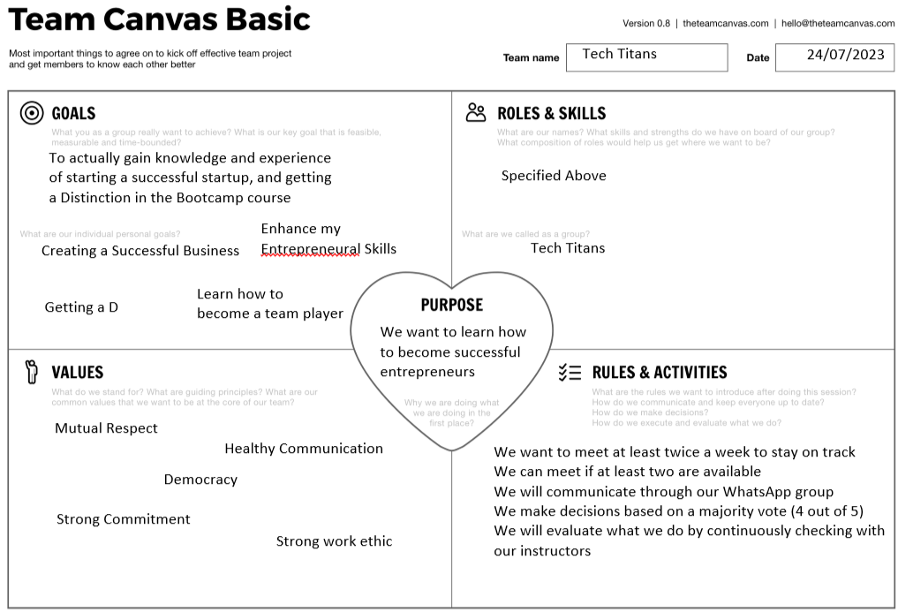  
Team Canvas Basics

**Mind maps:**

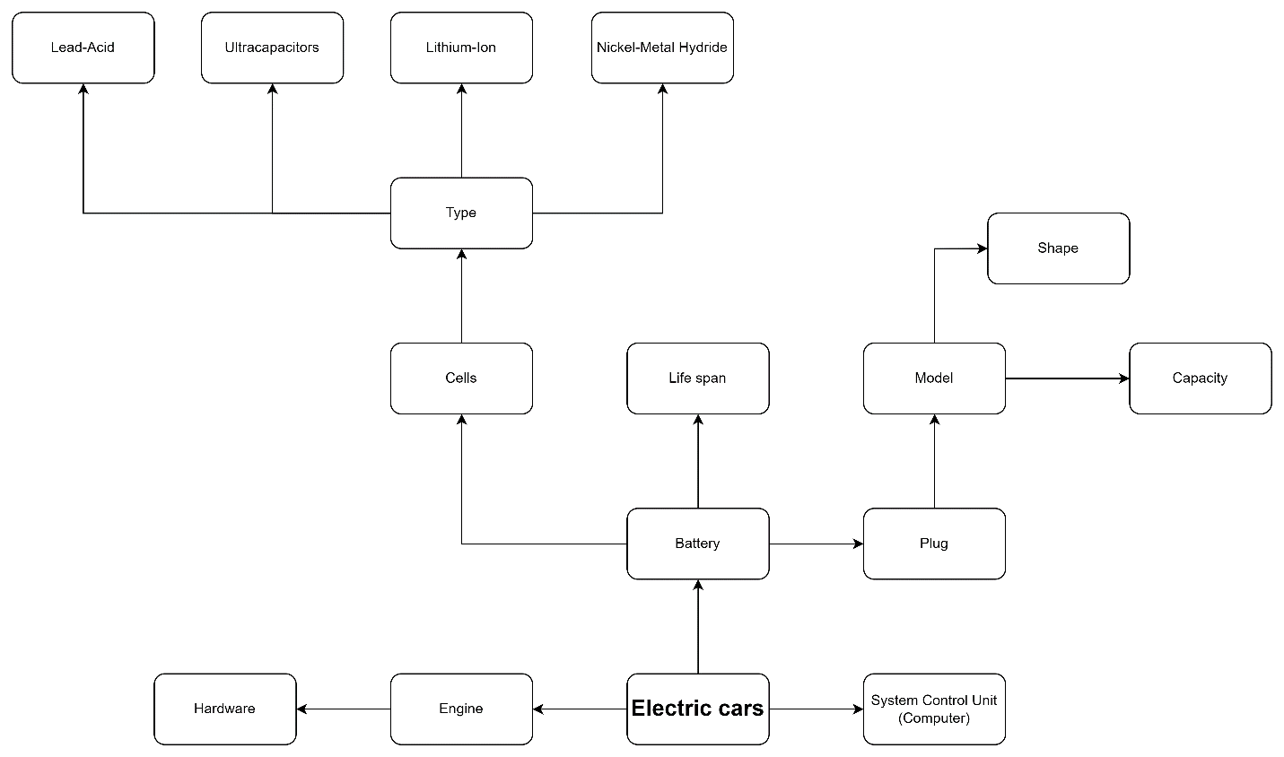

First Developed Mind Map

Identification 
Official Documents 
Visa 
Master cards 
Credit cards 
Types 
Public means 
Bank 
Waste 
Convenience 
Restaurants 
Loyalty cards 
Shopping 
Transport 
Environmental 
Recycling 
challenges 
Advantages 
Security 
Retail 
Gift 
Impact 
Economic 
PVC 
Buildings 
Access 
Types 
Plastic Cards 
Materials 
Systems 
Insurance 
Functionality 
NFC 
Overuse 
PET 
Game 
RFD 
Disadvantages 
Point collection 
Uses 
Game access 
Fraud risk 
Can be lost 
Data theaft 
easily 
Biodegradable 

Second Developed Mind Map

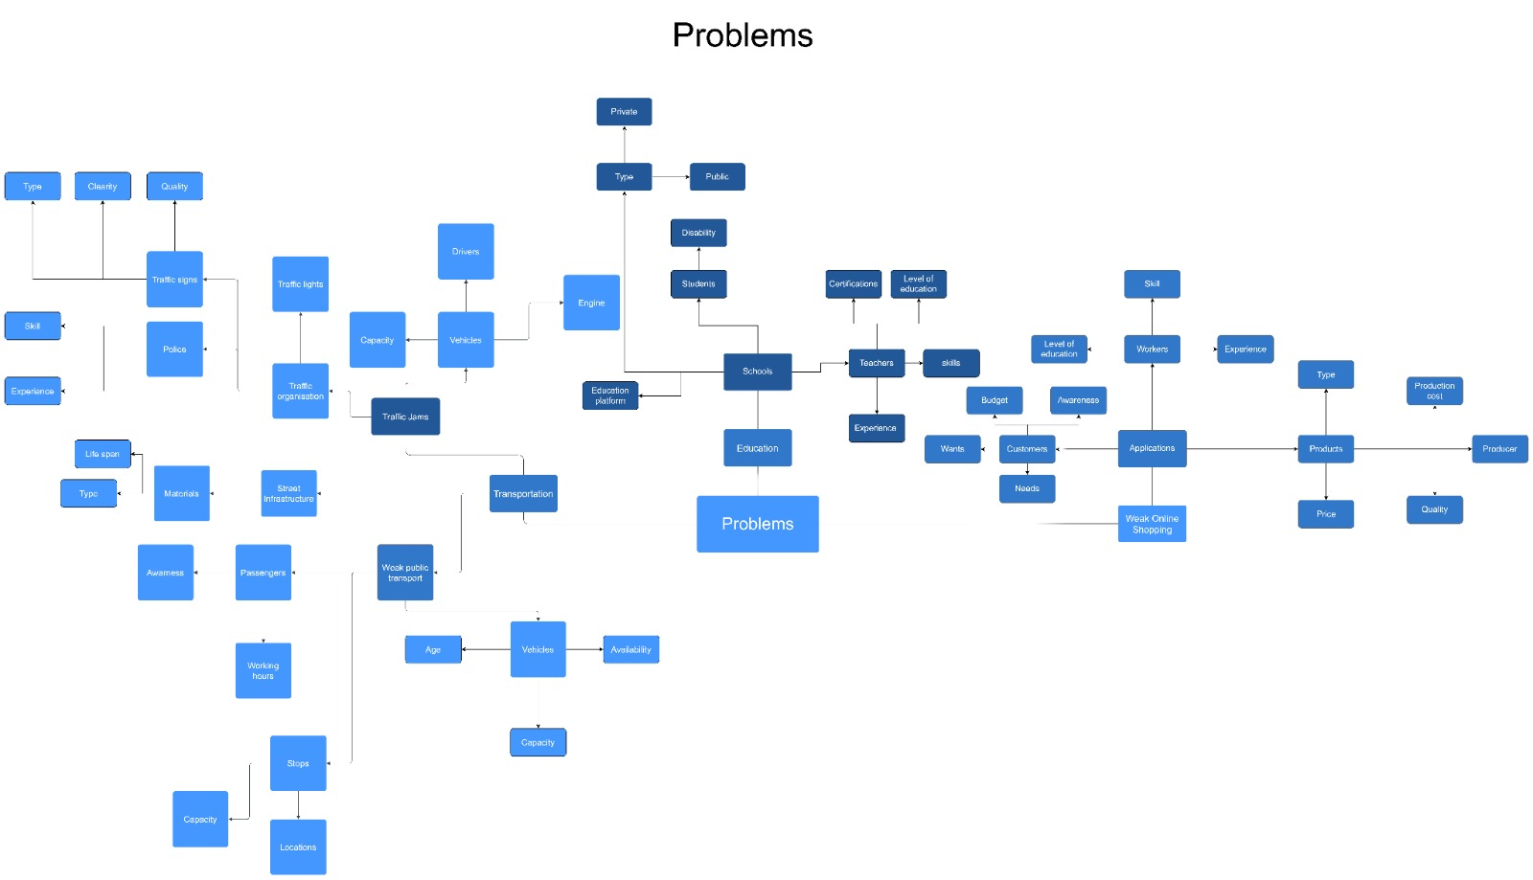

Third Developed Mind Map

Traffic law 
violation 
222!!!!! 
ΕΕΕ!!!!! 

Final Developed Mind Map

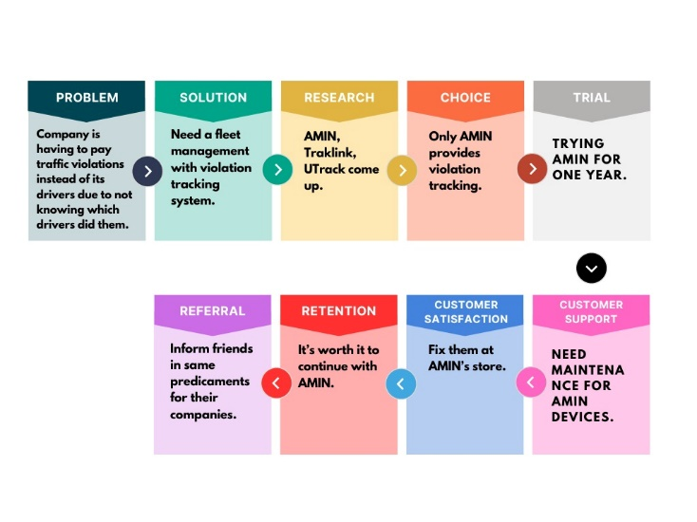

Customer Journey Maps

**Primary Research Data:** Interview with 4 companies/businesses and 1 expert:

* **Expert:** Dr. Lina Shabeeb
* **Company:** Al Sanabel/Baby Life
* **Company:** Eisberg
* **Non-Profit Organisation:** JEC Jordan
* **Local Bookshop:** Zaid Gifts Bookshop

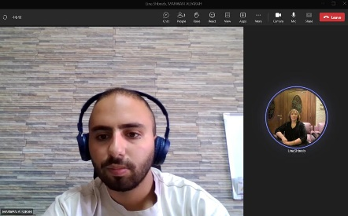

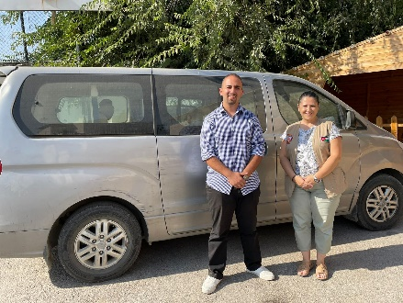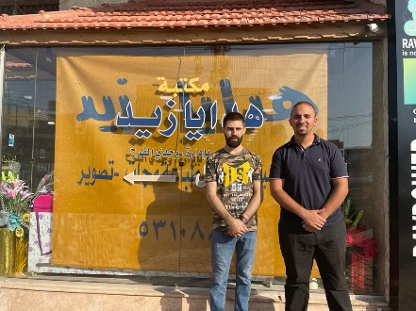

**PMR Results:**

1. **Inside Vehicle Monitoring Focus:** There is a consensus on the significance of monitoring behaviors inside the vehicle, particularly violations like not wearing seat belts and using phones while driving. This highlights a clear need for a solution that targets these specific behaviors.
2. **Integration of Technology:** The integration of advanced technologies such as AI, computer vision, and tracking systems is seen as a valuable approach to improving road safety and reducing traffic violations. These technologies can provide accurate and real-time monitoring, enhancing overall driver behavior.
3. **Behavioral Accountability:** The concept of driver accountability is crucial. Solutions should not only target violations but also focus on preventing accidents by addressing the underlying behaviors that lead to violations.
4. **Human Error and Responsibility:** Human error is a significant factor in traffic violations and accidents. Solutions need to consider the human element in conjunction with vehicle-related factors to effectively address road safety.
5. **Driver Reputation Management:** Some businesses already utilize driver rating initiatives for feedback. Implementing technology-driven solutions could help in improving driver performance and reputation management for companies.
6. **Supportive Infrastructure:** There is interest in exploring technology integration between vehicles and infrastructure, such as automatic speed reduction based on limits. This suggests that solutions should align with and enhance existing infrastructure.
7. **Impact on Business Reputation**: The impact of driver behavior on a company's reputation is recognized. Solutions that not only prevent violations but also contribute to better driver behavior could lead to enhanced business reputation.
8. **Variety of Use Cases:** The interviews showcase a range of business types, including a non-profit organization, local bookshop, and 2 large company. This diversity suggests that the proposed solution could have wide applicability across different sectors.
9. **Interest in Product Adoption:** Several interviewees express interest in adopting the product if its effectiveness is demonstrated. This suggests that there is potential for market acceptance and growth.
10. **Ethical Considerations:** While there is openness to the solution, concerns about privacy and potential resistance from drivers are highlighted. Solutions need to address these concerns transparently to gain acceptance.
11. **Lack of Driver Information:** Some organizations struggle with violations and accountability due to not having a record of driver information, especially in volunteer-based contexts. Technology could help address this gap.

**Secondary Market Research Results:**

* 1.474 billion cars exist worldwide, determining the Total Addressable Market (TAM) for car-related products/services12.
* Private companies in Jordan collectively own 455,192 vehicles, representing the Total Attainable Market (SOM) for specific services13.
* The global tracking system market is projected to reach $239 million with an annual market increase of 17.4%, showing market size and growth potential14.
* Jordan has witnessed 338 traffic accident-related fatalities in 2023, highlighting the significant impact on the population4.
* In 2022, Jordan experienced approximately 170,000 road accidents, indicating the scale of the problem8.
* Human error is responsible for 98.8% of traffic accidents, emphasizing the need for driver-focused interventions2.
* Only 13% of drivers and 8% of front-seat passengers in Jordan use seat belts, indicating low compliance[15].
* Around 93% of licensed drivers in Jordan use cellphones while driving, revealing a common safety concern7.
* Approximately 95% of traffic violations in Jordan go undetected, highlighting enforcement challenges5.
* Cellphone usage while driving contributes to about 90% of traffic accidents in Jordan, underscoring its significance5.
* Traffic accidents cost Jordan $350 million annually, accounting for 1% of the GDP, with substantial economic consequences2.
* Jordan records 600,000 traffic violations annually, emphasizing the prevalence of rule violations6.
* The cost of fleet management, monitoring and tracking systems costs an average of 10$ - 200$ per vehicle per month[16].
* Most vehicle management, monitoring and tracking systems cost approximately 13$ per vehicle per month[17].

## **Appendix 2 – Bibliography**

1 Department of Economic and Social Affairs of United Nation. “THE 17 GOALS | Sustainable Development.” Sustainable Development, 2022. <https://sdgs.un.org/goals>.

2 Jordan News. “Annual Road Accidents Cost Jordan JD 350M.” Jordan News, 2023. <https://www.jordannews.jo/Section-109/News/Annual-Road-Accidents-Cost-Jordan-JD-350m-Traffic-Police-Chief-30602>.

4 Roya News. “Traffic Accidents Claim 338 Lives in Jordan.” Roya News, 2023. <https://en.royanews.tv/news/43476/2023-07-30>.

5 Ammon News. “Qudah Calls for the Activation of Imprisonment and Fines Together for Serious Traffic Offenders.” Ammon News, 2023. <https://www.ammonnews.net/article/766534>.

6 FactJo. “600 Thousand Traffic Violations in Jordan Annually.” FactJo, 2023. <https://www.factjo.com/news.aspx?Id=181731>.

7 Ismeik, Muhannad, and Ahmed Al-Kaisy. “Characterization of Cell Phone Use While Driving in Jordan.” *Transport* 25, no. 3 (2010): 252–61. <https://doi.org/10.3846/TRANSPORT.2010.31>.

8 The Jordan Times. “Traffic Accidents Claimed 562 Lives in Jordan in 2022.” The Jordan Times, 2023. [https://jordantimes.com/news/local/traffic-accidents-claimed-562-lives-jordan-2022-—-interior-minister#:~:text=Traffic accidents claimed 562 lives in Jordan in 2022 — Interior minister,-By JT - Mar&text=AMMAN — Minister of Interior Mazen,of life on the ro.](https://jordantimes.com/news/local/traffic-accidents-claimed-562-lives-jordan-2022-%E2%80%94-interior-minister#:~:text=Traffic%20accidents%20claimed%20562%20lives%20in%20Jordan%20in%202022%20%E2%80%94%20Interior%20minister,-By%20JT%20-%20Mar&text=AMMAN%20%E2%80%94%20Minister%20of%20Interior%20Mazen,of%20life%20on%20the%20ro.)

12 Hedges Company. “How Many Vehicles Are in the World.” Hedges Company, 2021. <https://hedgescompany.com/blog/2021/06/how-many-cars-are-there-in-the-world/>.

13 Al Salam News. “The General Traffic Department Reveals a Statistic of the Number of Vehicles.” Al Salam News, 2021. <https://nabd.com/s/97805943-ca3559/>.

14 Fact MR. “Fleet Management Market Size, Demand & Growth Report 2032.” Fact MR, 2022. <https://www.factmr.com/report/fleet-management-market>.

15 Alomari, A. H., and M. M. Taamneh. “Front-Seat Seatbelt Compliance in Jordan: An Observational Study.” *Advances in Transportation Studies* 52 (2020): 101–16. <https://doi.org/10.4399/97888255370317>.

16 Force by Mojo. “What Does a GPS Fleet Tracking System Cost In 2023?” Force by Mojo, 2023. <https://forcebymojio.com/blog/what-does-a-gps-fleet-tracking-system-really-cost/>.

17 Watts, Julia. “Vehicle Tracking Costs | How to Save Money & Avoid Charges.” Expert Maret, 2023. <https://www.expertmarket.com/au/vehicle-tracking/vehicle-tracking-systems-cost>.

1. Department of Economic and Social Affairs of United Nation, “THE 17 GOALS | Sustainable Development.”
2. Jordan News, “Annual Road Accidents Cost Jordan JD 350M.”
3. Al Sanabel/Baby Life Company Interview
4. Roya News, “Traffic Accidents Claim 338 Lives in Jordan.”
5. Ammon News, “Qudah Calls for the Activation of Imprisonment and Fines Together for Serious Traffic Offenders.”
6. FactJo, “600 Thousand Traffic Violations in Jordan Annually.”
7. Ismeik and Al-Kaisy, “Characterization of Cell Phone Use While Driving in Jordan.”
8. The Jordan Times, “Traffic Accidents Claimed 562 Lives in Jordan in 2022.”
9. JEC Jordan and Zaid’s Gifts Bookshop
10. Al Sanabel/Baby Life Company Interview
11. Eisberg Company Interview
12. Hedges Company, “How Many Vehicles Are in the World.”
13. Al Salam News, “The General Traffic Department Reveals a Statistic of the Number of Vehicles.”
14. Fact MR, “Fleet Management Market Size, Demand & Growth Report 2032.”
15. Alomari and Taamneh, “Front-Seat Seatbelt Compliance in Jordan: An Observational Study.”
16. Force by Mojo, “What Does a GPS Fleet Tracking System Cost In 2023?”
17. Watts, “Vehicle Tracking Costs | How to Save Money & Avoid Charges.”